Big data
Big data is also data but with a large size. Big data is term used to describe the collection of data that is in huge size and yet growing exponentially with time. In short such data is so large and complex.
Ex:- 1)new York stock exchange generates about 1 terabyte of new data per day 2)social media
Types of data
Structured :- any data that can be stored, accessed and processed in the form of the fixed format
Ex:- employee table in database
Unstructured :- any data with unknown form & structure ex:- o/p return by the google
Semi structured :- contains both the form of data ex:- personal data stored in xml file
Characteristics
- Volume:- refers to vast amount of data generated every second like zetta byte or bronto bytes Distributed system is use to store & analyze here
- Variety:- refers to heterogeneous sources and nature of data both structured & unstructured. Early days Spreadsheet & databases are only source now a day’s data in the form of photo, email, audio, video, pdf etc
- Velocity:- refers to the speed of generation of data. How fast data is generated and processed determines potential of the data
- Veracity:- refers to inconsistencies and uncertainty in data that is available data sometimes get messy and quality and accuracy are difficult to control. Big data creates confusion less data gives incomplete info.
- Value:- data in itself is no use or importance but its need to convert into something valuable to extract info hence you can state the value
Traditional vs big data
Data is structured data in traditional data | Data is unstructured or semi structured
Size of data is small | Size of data is large & complex
Data source is centralized | Data source is distributed
Easy to handle or processed | Difficult to handle data
Traditional dataset tools are enough | Special kind of tools needed
Data stored in RDBMS | Data stored in noSQL,HDFS

BIG DATA challenges
- Company struggle to find right talent capable of working with new technology
- Data access and connectivity can be obstacle
- Cost escalate too fast if right kind of data is not captured

Examples and application
- Monitoring health conditions through data from wearable’s
- Live road mapping for vehicle
- Media streaming

HADOOP
Hadoop
Hadoop is an open source framework for storing and processing data in distributed way across clusters of the computers
Its provides massive storage for any king of data & processing power
Features and principals
- Open Source: Hadoop is open-source, which means it is free to use
- Highly Scalable Cluster: Hadoop is a highly scalable model from single server to 1000 of server
- Fault Tolerance is Available: ...
- High Availability is Provided: ...
- Cost-Effective

Components of hadoop

Hadoop common package:- contains libraries and utilities required by other hadoop modules jar file &script to start hadoop.
Hdfs:- 1) provide interface for managing file system. 2)creates multiple replicas of data block & distribute them on computers.
Components of hdfs:-
- Namenode:- is master contains metadata manages blocks present on datanodes. Take care of authentic
- Datanode:- is slaves provides storage , responsible for read & write req for the clients send heartbeats and block reports to namenode
Hadoop mapreduce:- use to distribute work around clusters, mapreduce process are divided into two jobtracker & tasktracker
- Jobtracker:- is master responsible for scheduling job & managing resources in clusters
- Tasktracker:- is slaves responsible for running map & reduce tasks instructed by job tracker
Yet another resource negotiator(YARN):- is resource management platform responsible for managing copute resources in
Clusters and using them for scheduling of users application.

Hadoop ecosystem

Hadoop Ecosystem is a suite which provides various services to solve the big data problems. It includes various commercial tools and solutions.
HBase: columnar Database. That sits on top of HDFS. Based on column rather than rows
Hdfs vs hive
Hdfs is suitable for storing large file hive is relational DBMS
HDFS provides seq access of data hive provide random access of the data
HIVE: Query based processing and accessing of data. Use hives query lang HiveQL
HCatlog:- is a metadata & table storage management
pig :- is a scripting platform use pig latin language for scripting
Mahout: Machine Learning & data mining algorithm libraries
Oozie: Job Scheduling
Zookeeper: Managing cluster coordination like maintaining config info provide synchronization
Sqoop :- Data Integration Services. Transfer data in both ways SQL to Hadoop vice versa
Spark: In-Memory data processing

Hadoop limitation

- Not fit for small data
- Vulnerable by nature:- hadoop use java which is widely used lang by cyber criminals
- Security:- hadoop not provide encryption at the storage
What is NoSQL?
- NoSQL is database management system that provides mechanism for storage & retrieval of massive amount of unstructured data in distributed environment on virtual servers to provides scalability ,availability etc.
- NoSQL is databse which is completely different from traditional database.
- SQL as well as other query languages can be used with NoSQL.

(Non-relational database, free of joins , can be manage huge amount of data)

Difference bwtween SQL & NoSQL?
SQL | NoSQL
Relational Database management system | distributed database management system
SQL databases are vertically scalable | NoSQL databases are horizontally scalable
SQL databases have a predefined schema | NoSQL databases use dynamic schema
Suitable for complex query language | Not Suitable for complex query language
SQL databases are not suitable for hierarchical data storage. | More suitable for the hierarchical data store as it supports key-value pair method.
 | Ex. MongoDB, Redis, , Neo4j, Cassandra, Hbase
  Ex. Oracle, Postgres, and MS-SQL

nosql data architecture patterns
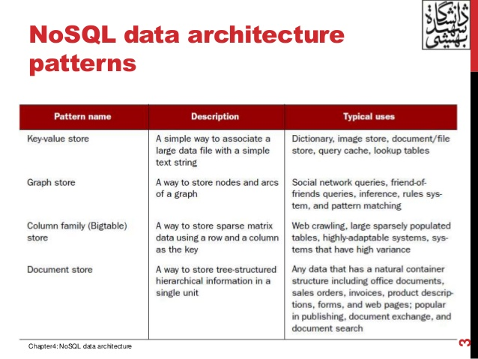

MongoDB
- MongoDB is a document database that provides high performance, high availability, and easy scalability. Stores data in JSON document.
- that bridges the gap between key-value and traditional RDBMS systems.
Map tasks
the all inputs to the map task is key value pair. The map function converts input into key value pairs. Like word count example map function read document break into sequence words and convert into key value pairs.
Grouping by key
When all map task completed the key value pairs are grouped by key and value associated with key are formed into list of values
Reduce task
Argument to the reduce is the key and list of values. Outputs of the reduce tasks are merged into single file.
Combiners
Some of the tasks of reduce assigned to combiner instead of sending all the mapper data to reducers some values are computed in the map side itself by using combiner and then send to reducer
Mapreduce execution ->>input data->mapper->shuffle sort->reduce

